Corona Plateau Mauritius

Newsletter November 2021
Next meeting November 19th

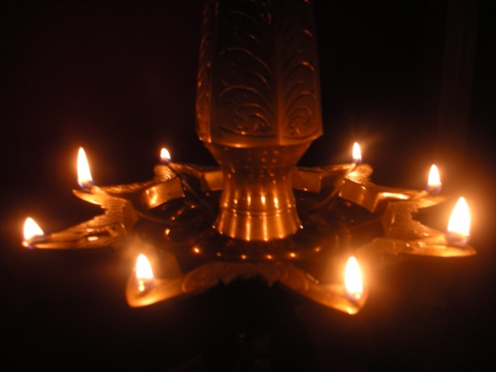

Welcome to the Newsletter for November. This month we are celebrating Divali, the festival of Light . i think we all know that coloured lights are placed in gardens. Ladies wear their fancy saris and churidars, and everyone enjoys the sweetmeats and cakes made by the grannies, mothers and aunties of households. This month we have invited Mrs. Chelahshah Hamal Desha, a former headteacher, to talk to us about the deeper meaning of Divali, and we look forward to what she has to tell us.

We in turn, will put on our pretty dresses for the occasion, and enjoy the cakes that some of our members will bring to share with us all. Not necessarily traditional cakes, but anything that we are happy to make and know that everyone will enjoy.
Let’s make it a fun morning, full of happiness, especially in these turbulent times.
Our October meeting was a great success. So many plants and cuttings were offered and exchanged by our ladies . We obviously have many gardening enthusiasts in our midst, who enjoyed an assortment of readily available plants and some less known varieties. Many thanks to all those who participated in this exchange.
The raffle prize was a continuation of the morning’s activities. Lyndsay brought a lovely bouquet of white blooms. This was one by Emilie, one of most enthusiastic flower growers. Well done Emilie.
Fifi kindly offered to bring the raffle prize for November.
We learnt a few days ago that Manda Boolell has sustained a fracture of her femur, and will be out of action for some weeks. We wish her a speedy recovery and hope to see her soon. In the meantime, we have taken some flowers to her on behalf of Corona Plateau and wish her a Happy Divali, in spite of her circumstances.
ANNOUNCEMENTS FOR THE NEXT TWO MONTHS
On the 25th November, the Chairwoman of Corona Worldwide, Yvette Bavin, will be visiting Mauritius on holiday. She has expressed the wish to meet a few of the Corona members here, and it was thought that the Gymkhana club would be a suitable place for her to meet us. It will be an informal meeting, and if anyone is interested to be present, please contact me, Rosemarie on 5721 5286 We shall of course take souvenir photos of the occasion.

Asha will be our gracious hostess at a tea party in her home in Moka. The provisional date has been set for Friday, 3rd December. We do hope that you all come to visit her wonderful garden and relax under the trees on that day, as well as enjoying the delicious teatime fare which will be on offer. Please don’t forget that we shall collect Rs. 100 from each member or guest present for our fund raising activites.
Our December meeting will take the form of a Christmas lunch, instead of the usual meeting. Details will be sent to you as soon as possible, but the date will be the same as the scheduled meeting, that is Friday 17th December. Please make a mark in your diary
We are inckuding for your information the mobile numbers of the committee. Should any of you have any information to give us relating to Corona activities, please feel free to contact any us.
Chairwoman: Rosemarie 5721 5286
Secretary/Admin: Kamini 57557266
Treasurer: Asha 58274055
Events/Speakers: Lyndsay 57774351
Admin asst: Lata 59807208
Admin asst: Mira 57777718

