**Corona Plateau Mauritius**

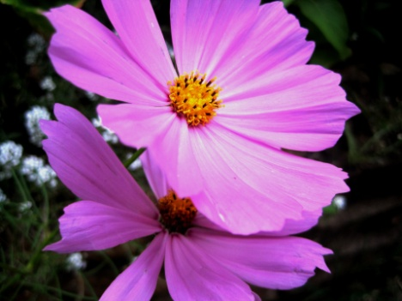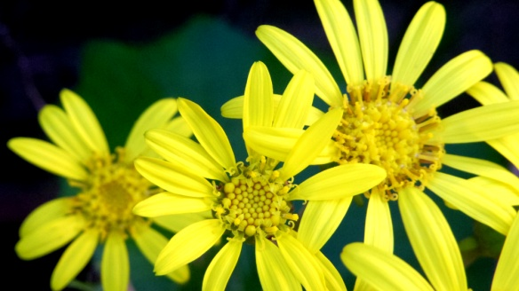

**Newsletter October 2021**

**Next meeting October 15th**

Welcome to the Newsletter for October, which as you can see, will feature your plants and flowers. We hope that as many of you as possible will bring plants and cuttings to swap and share. If any of them are rare and valuable, you could ask for a small price for them to boost up the Corona charities fund. Hopefully, some of you avid plant growers will hold a table and give advice on plant growing, taking cuttings etc. A good morning in perspective!

Our September meeting began with the sombre news about one of our oldest members, Solange Gale, who sadly passed away recently. Solange had been a very active member until ill health made it impossible for her to attend our meetings and outings. Fortunately we managed to take her some flowers just before this last lockdown. She was very happy to see us, but it was evident that she was not in the best of health even then. A card was available at the meeting, and all ladies who wished to sign it in remembrance of Solange could do so. As soon as possible, we shall take some flowers to her grave in Curepipe.

The rest of the meeting was deemed to be a great success by those ladies present. Mira and Kamini did us proud. Mira gave a most interesting talk on the fish that is caught and eaten in our waters. She strengthened this by providing colourful posters of all types of fish available and tips on how to buy fish at local markets and fish vendors. Thank you Mira for this most interesting and informative talk.

Kamini followed Mira and gave us a demonstration on how to cook and prepare a fish béchamel. This was followed by a tasting of her dish. We are including the recipe for this, as we are sure that a lot of ladies would like to cook this at home

**Recipe for Bechamel fish:**

* 500 grams fish filet (Kamini used Capitaine fish) boiled and flaked
* 1 medium onion, chopped, 1 small tomato, chopped
* Thyme and parsley
* 200 ml milk mixed with 2 level tablespoons of cornflour
* 100 gm grated cheddar

Method: Heat butter, cook onion and tomato. Add cooked fish and thyme and cook for 2-3 minutes. Mix milk with cornflour, add to pan. Stirring constantly, let the sauce thicken. Add the cheese and lastly the parsley. The dish can then be covered with breadcrumbs and browned in the oven if desired.

We ended the meeting by drawing the monthly raffle prize ticket. This time Binita kindly offered the raffle prize, a wonderful multiple photo frame. This was won by Fifi. Well done Fifi. Next month’s prize will be donated by Lyndsay.

**Advanced notice: November meeting will celebrate Divali. You are invited to wear something appropriate for the event and make it a fun time. Traditional cakes wil be available, as well as the usual snacks. A special speaker will come and talk to us about the meaning of Divali. She is Mrs. Sheila Desha, a retired college rector, highly involved in education and sports activities. More about this in the next newsletter.**

We are inckuding for your information the mobile numbers of the committee. Should any of you have any information to give us relating to Corona activities, please feel free to contact any us.

**Chairwoman: Rosemarie 5721 5286**

**Secretary/Admin: Kamini 57557266**

**Treasurer: Asha 58274055**

**Events/Speakers: Lyndsay 57774351**

**Admin asst: Lata 59807208**

**Admin asst: Mira 57777718**

C:\Program Files\Microsoft Office\MEDIA\CAGCAT10\j0281904.wmf